How to integrate ldap server with Hadoop cluster.

1. I have installed open ldap server in one dedicated machine.
2. That machine openldap service should be up and running fine.
3. If phpldapadmin is being used, then httpd service also should be up and running fine

Commands:

service slapd status

service httpd status

1. After that I verified, below URL whether PHPLDAP admin working fine or not.

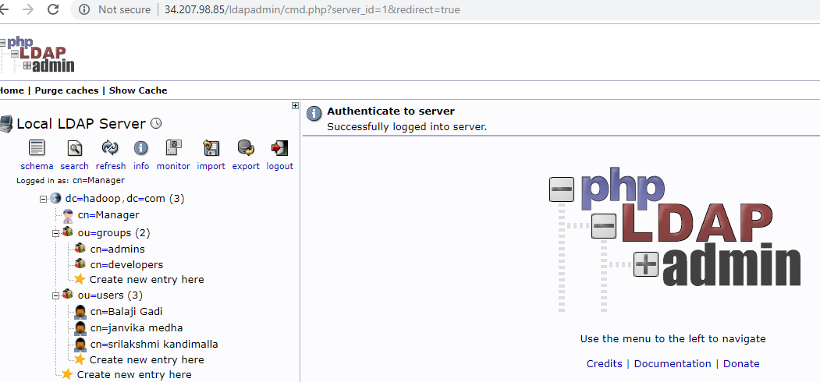

1. Once this being done, in all Hadoop clusters we need to run some package to integrate this openldap with Hadoop cluster.

I am running below command to install in all machines.

yum –y install nss-pam-ldapd

1. [root@ip-172-31-37-72 ~]# authconfig --enableldap --enablemkhomedir --ldapserver=ldap://ip-172-31-36-106.ec2.internal:389 --ldapbasedn="dc=hadoop,dc=com" --update

Starting nslcd: [ OK ]

1. Above ipaddress is ldapserver ipaddress.
2. Then I run below users, its successfully authenticated in Hadoop client machine.
3. Below users I created in openldap server, but I can see below users successfully authenticated in Hadoop client as well.

Command is

authconfig --enableldap --enablemkhomedir --ldapserver=ldap://ip-172-31-36-106.ec2.internal:389 --ldapbasedn="dc=hadoop,dc=com" --update

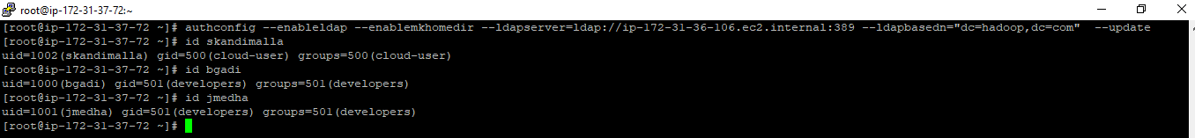

Above is Hadoop node, users are successfully authenticated.

Authconfig-tui screenshot

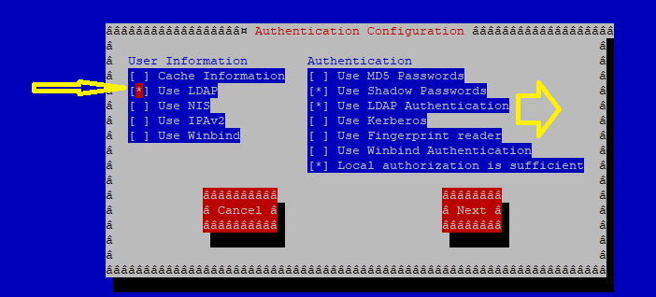

After clilcing next , you would see ldap server is detecting or not.

Similar steps doing in other Hadoop machines as well.

Installing nss-pam-ldapd

& enabling authconfig command

& authconfig-tui

